Summary

LinkLoom is an advanced bookmark manager that goes beyond the standard web browser options. The application, hosted in the cloud aims to offer an easy-to-use, customizeable and extendable bookmarking experience. The philosophy of the project is to let users create their own collections of bookmarks, organize them as they wish, share them and even publish them to the featured section of the site. Additionally, users can clone existing lists published by someone else to extend them as they please.

Architecture
LinkLoom is full-stack application with the following stack
- MongoDB - NoSQL database for dynamic, object-oriented data storage
- Express/Node.js - Minimalist web application framework
- EJS - Simple templating language based on HTML for easy view creation

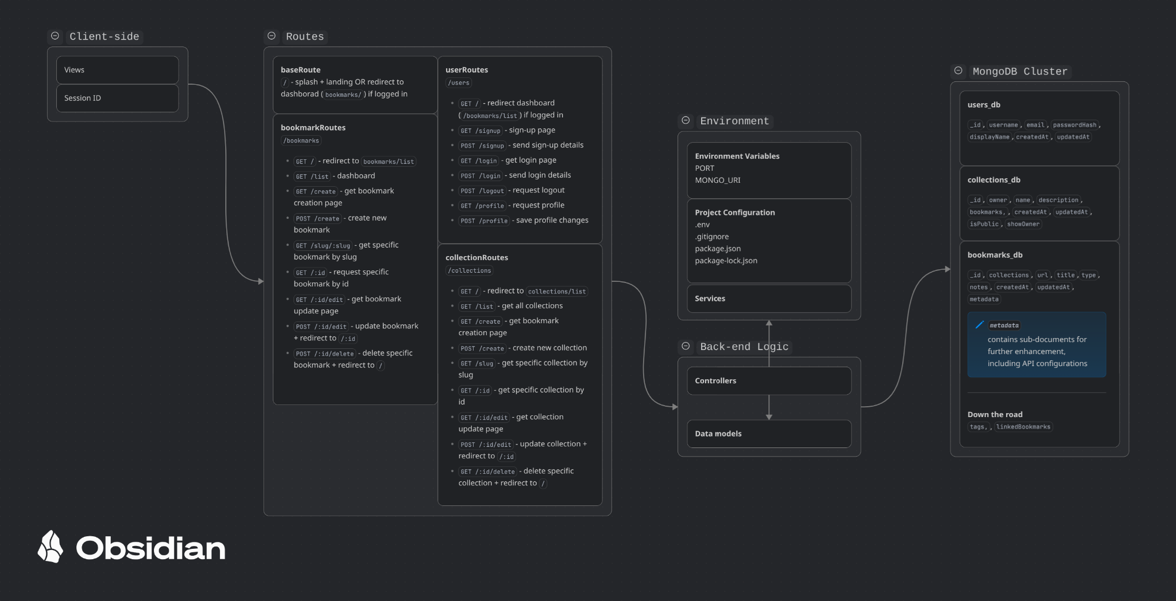

Features
To provide an enriched bookmarking experience, _project-ame_ will include the following features:
- Bookmark CRUD
- Collections, Tagging & Inter-bookmark linking
- User accounts
- Public & Private lists
- Collection cloning and merging

To enhance the bookmarks, LinkLoom also makes use of the following APIs
- OpenLibrary
- OpenAlex
- OpenGraph

More integrations will be added to enable an even better bookmarking experience.

Web pages will include
- Landing/Splash Page
- Public lists page
- My Lists page

Possible Future Additions
Features that may be added in the future
- Shared bookmark space
- User MFA
- More API integrations
- Bookmark import and export
- Compose-able collections
- Browser extensions

